Semester 2 Final Project Report

Online Banking System

Marcell Septian – 2201798906

Programming Languages

Binus University International

Table of Contents

1. Project Specification 3

2. Solution Design 3

3. Explanation of Functions and Classes in the Files 4

4. UML Chart 9

5. Evidence 11

6. Lessons Learned 15

7. Problems overcame 16

8. References 17

“Online Banking System”

Name: Marcell Septian

ID: 2201798906

# Project Specification

This program is about an online banking system which has various functions such as deposit, withdraw, check balance, transfer, and see the transaction log or transaction history. In this program, you could register once you open the login form or register in the bank which requires the admin to register it for you so you could enter the balance directly. By registering yourself, your current balance will start with 0 as you don’t insert any balance and your bank id will show up once you signed into your account. Furthermore, this program can do a real time transaction which means that if you transfer your money to someone, the money will go into their account once you succeed your transaction.

This application has a real time help as well since you could ask for help to our customer service which will help you 24/7. They could know when you are connected to them or not and they will directly answer you once you have been connected to their server as there will be a notification popup in their computer and will reply back to you once you are connected. However, it is in a different application so you will be given two application which is the banking system and help application that is provided 24/7 to help you if you don’t understand something about our banking system. Also, the admin can see your details but they cannot see your username and password as they were protected so that your account won’t get hacked by anyone and no one can use your account as it is protected.

# Solution Design

The design of my project started when I learn on how to use the database program which is the mySQL. Firstly, I learn about the mySQL language which were taught in the TA class. Then, I tried to figure out the implementation of the mySQL so that I could get the data and return it to be compared to another variable. Once I tried to insert the data into a list, I tried to make the text based program and after succeeding on making the program, I moved on to makin the graphical user interface.

On the process of making the graphical user interface, I went through lots of problem as I need to change my IDE from IntelliJ to netbeans which made me feel uncomfortable and it is quite hard to adapt at the beginning. But as I learned more about swing as the graphical user interface, I try to understand the code and how to use it and modify everything by searching as well. After that, I learned on how to put a notification and make a chat server without implementing it in the same GUI as the other code.

# Explanation of Functions and Classes in the Files

## DatabaseInterface.java

## This is an interface which is the blueprint of what I will be making for the banking system. Inside the interface I only have 4 functions that will get override in the database class. The four functions are:

* Boolean login(String x, String y)
* Int addBalance(int id, int x)
* Int subtractBalance(int id, int x)
* Int checkBalance(int x)

## Database.java

This file contains almost all function regarding the usage of mysql such as add, delete, update, etc.

### Void addData(String name, int age, String email, String username, String password):

* Enter the query of the mysql to insert data into the user database with the parameters.
* Let the preparedstatement read the query
* Set the data that wanted to be inserted
* Set the balance into 0 because this function is used when the user is registering by themselves.
* Execute the query and close it

### Void updateAdd, updateSubtract(int id, int balance)

* Enter the query of the mysql to update data inside the user database with the parameters.
* Let the preparedstatement read the query
* Set the data of the balance that wants to be updated using the addBalance or subtractBalance function to increase or decrease the balance
* Set the id of the user
* Execute the query

### Void delete(int id)

* Enter the query of the mysql to delete data of the user database with the parameters.
* Let the preparedstatement read the query
* Set the id that wants to be deleted
* Execute the query
* Reset the increment using resetIncrement function

*Void resetIncrement():*

* Enter the query of the mysql to reset the id of user so that there won’t be any id to be useless.
* Let the preparedstatement read the query
* Execute program

*List getUser():*

* Checking the data of the user inside database
* Making an object with all of the data inside the database and adding it to a list
* Return the list

*Int checkBalance(int id):*

* Checking the balance through the list from the getUser function
* Once the id inserted match with the id inside the list
* It will return the amount of balance

*List getLog():*

This function is used for the transaction log database.

* Checking the data of the user inside database
* Making an object with all of the data inside the database and adding it to a list
* Return the list

*addTransactionlog, deleteTransactionLog:*

* It is the same as addinig and deleting data in the previous one but for different database

*Boolean login(String username, String password):*

* Iterating through the listuser from getUser function
* Checking if the username and password is correct or not
* Return true when it is matched

*Int addBalance(int id, int balance):*

* Getting the balance and adding the balance from the parameter to the balance inside the database
* Return the result of the addition

*Int subtractBalance(int id, int balance):*

* Getting the balance and subtracting the balance from the parameter to the balance inside the database
* Return the result of the subtraction

## Admin.java

This file consists of the function that will be used in the admin form. There are 10 functions inside the admin class and this class is the child class of the database class as it inherits form the database class so it could use the functions in the parent class.

*void addAcount(String name, int age, String email, String username, String password, int balance):*

* Enter the query of the mysql to insert data into the user database with the parameters.
* Let the preparedstatement read the query
* Set the data that wanted to be inserted
* Execute the program and close it

*int checkTotalBalance():*

* Initialize the total variable and set its value to 0
* Use the getUser function which returns a list and insert it into the listuser which has the class user as its properties.
* Iterate through the list and get the total balance by adding the balance everytime it iterates through the index.
* Returns the total amount

*List getID, getName, getEmail, getBalance, getUsername, getPassword():*

* Use the getUser function which returns a list and insert it into the listuser which has the class user as its properties.
* Make a new list
* Iterate through the listuser and add all information into the list

## People.java

This file consists of functions that are used by the users and this is the child class of Database as it inherits from the database class.

*Int checkID(String username, String password):*

* This function is to get the id from the username and the password

*Boolean login(int id):*

* This function is to set the boolean value into true if the id is correct with the one in the database to log onto the next form.

*String getName(int id):*

* This function is to return the value name based on the id.

*Void transfer(int myid, int theirid, int balance):*

* This function is to transfer the money by subtracting the sender’s balance and adding the receiver’s balance by using the updatesubtract and update add function.

*Void withdraw(int myid, int balance):*

* This function is to withdraw money by using the updatesubtract function and subtracting our balance.

*Void deposit(int myid, int balancee):*

* This function is to deposit money by using the updateadd function and adding our balance.

## Login.java

This is a graphical user interface form which uses swing. This page will show the login page of the program which decides if the user can go onto the next frame or not by entering their username and password.

## Register.java

This form is to register data and input them into the database. After registering, the user could directly access their account from the login form and it could go through it and the userform will be shown.

## AdminForm.java

This file is the graphical user interface for the admin which lets the admin to have authorities to see the user’s details excluding username and password. They could add users as well and delete them.

## UserForm.java

This file is the graphical user interface for the user which lets the user to check their balance, deposit money, withdraw money, transfer, and check their transaction log. The form is filled with buttons with different purposes.

## CheckBalanceForm.java

This form is showing the current balance that the users have currently with only a back button to show the previous frame.

## DepositForm.java

This form’s function is to deposit money for the users. The users just need to enter the amount of money that they wish to input and click the button to proceed to depositing the money and their balance will increase.

## WithdrawForm.java

This form is used to withdraw money for the users. The users need to input the amount of money they wish to withdraw and after they click the button their balance will get deducted based on the amount of money they inputted.

## TransferForm.java

This form is to transfer money from one user to another user. So the user needs to search for the other user’s id and input them. After inputting them, they need to click on their id and enter the amount of money they wish to transfer. After proceeding with the transfer, the balance in the user will be deducted and the balance in the opposite side will increase.

## TransactionLogForm.java

This form shows the transaction history that happened throughout the entire time. The user could clear the transaction log as well by clicking on the button provided.

## Server.java

This file is a different application and has no connection to the other form. This is a graphical user interface for the admin to chat to the client. It could send the data and it can detect if a user had been connected to its server by using a notification.

## Client.java

This file is connected to the server file which lets the client to chat to the server and if there is no server running there will be a warning message that shows that they cannot use the program.

# UML Chart

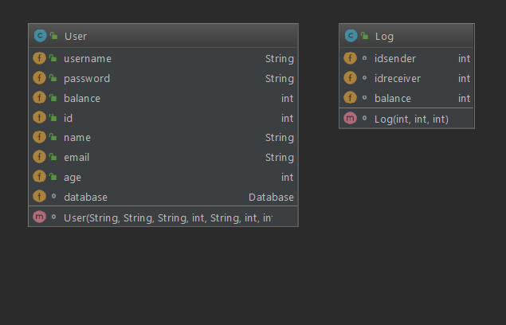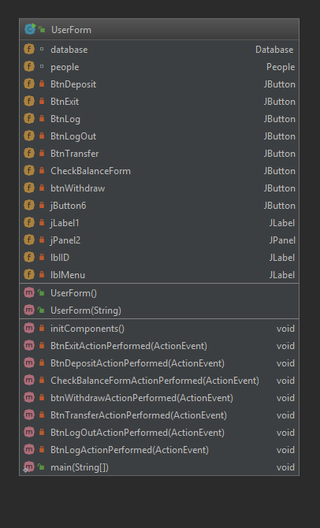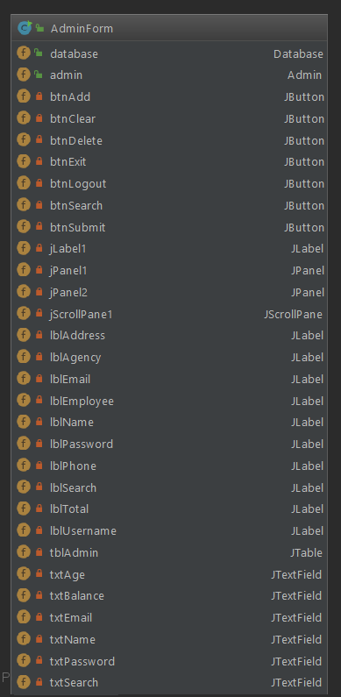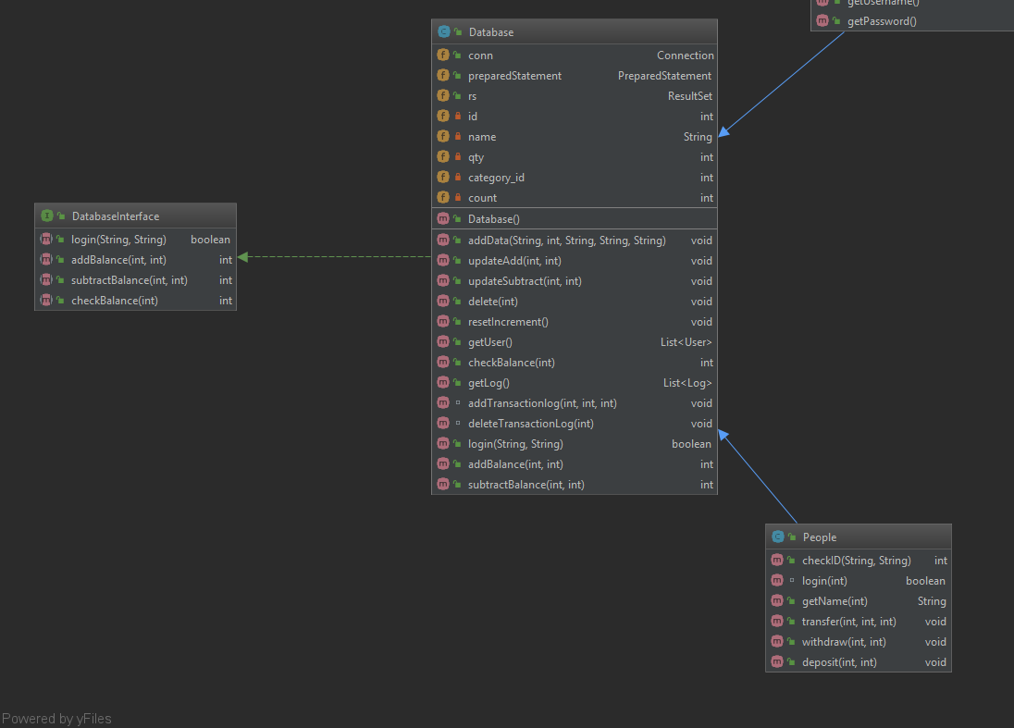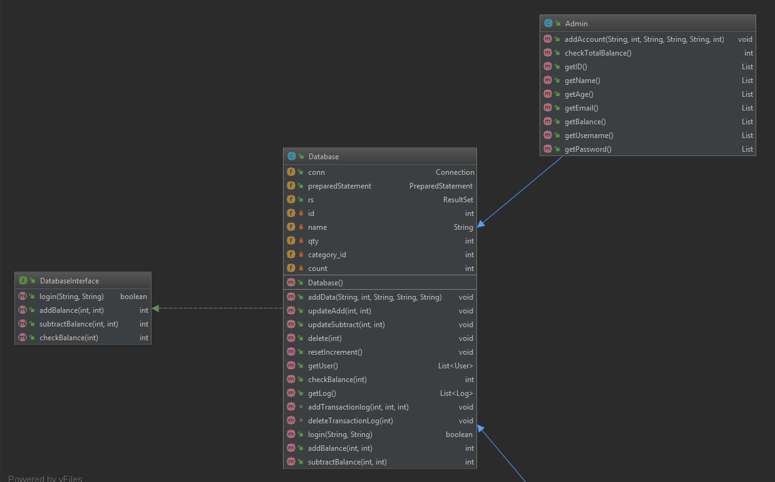

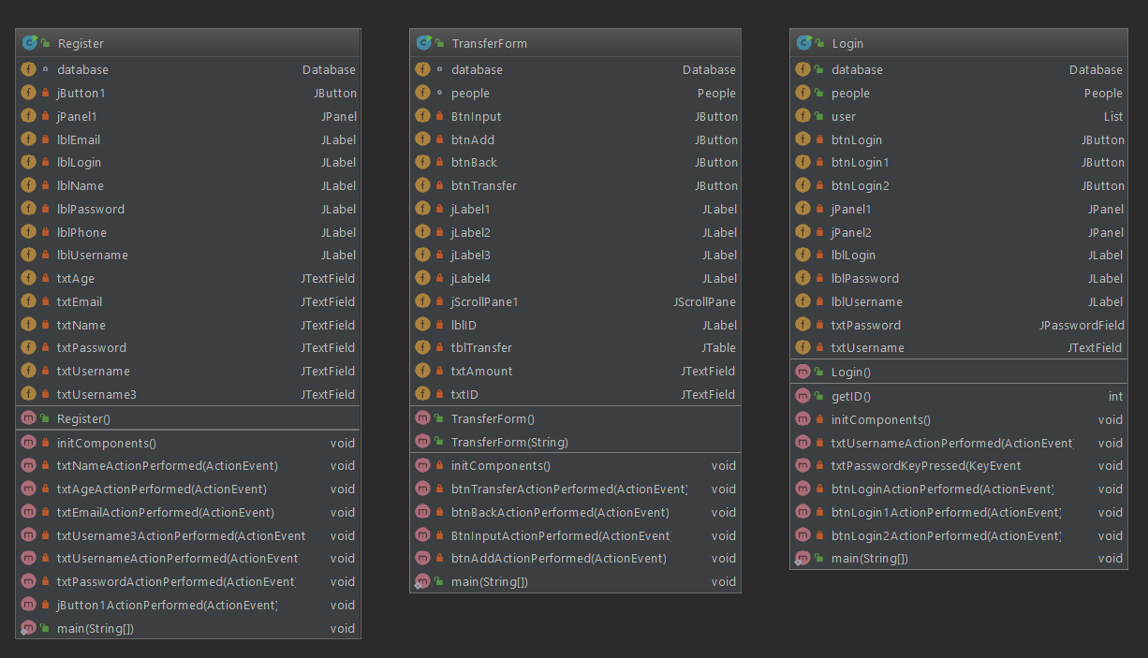

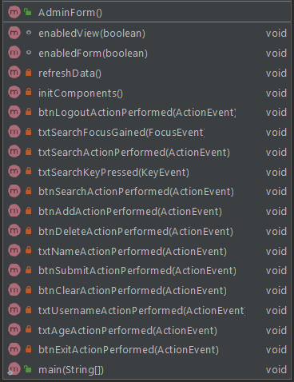

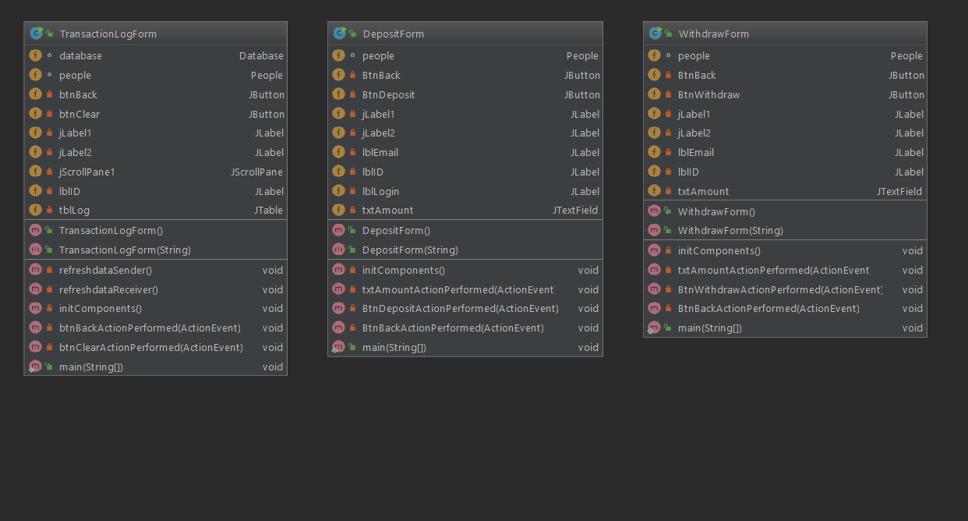

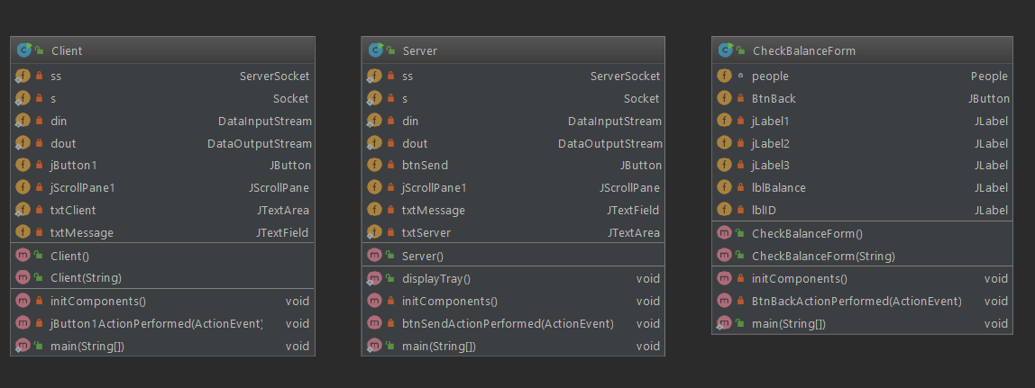

# Evidence

Here is the evidence of the working program that I made.

x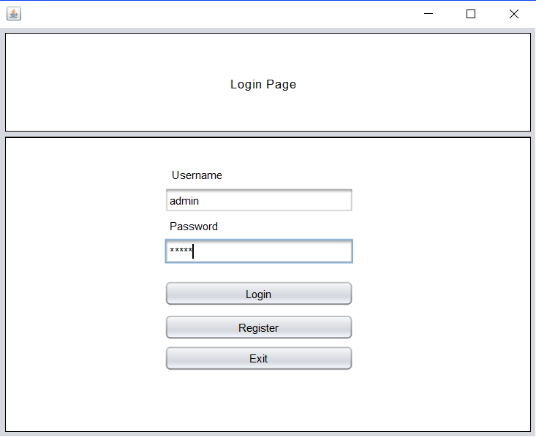

# This is the login form that shows the user filling in the username and password. The password doesn’t show the word and it is changed into stars.

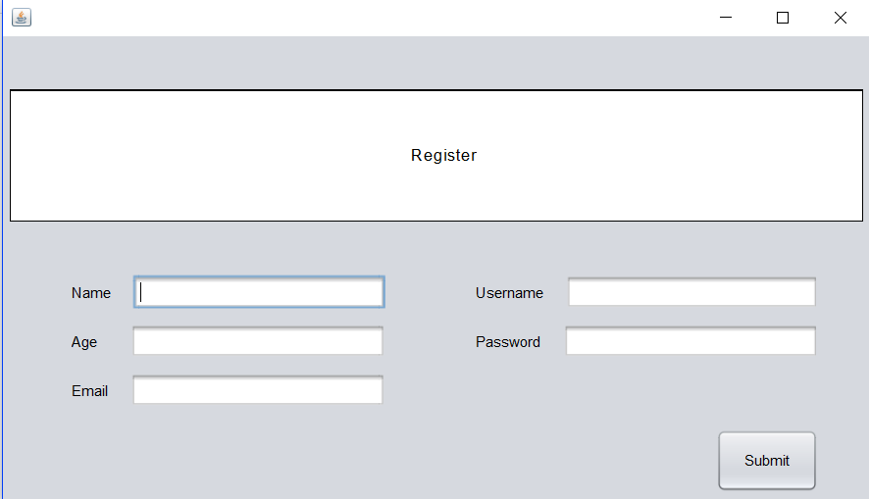

This is the register form to register and have a new account which can be seen in the login form.

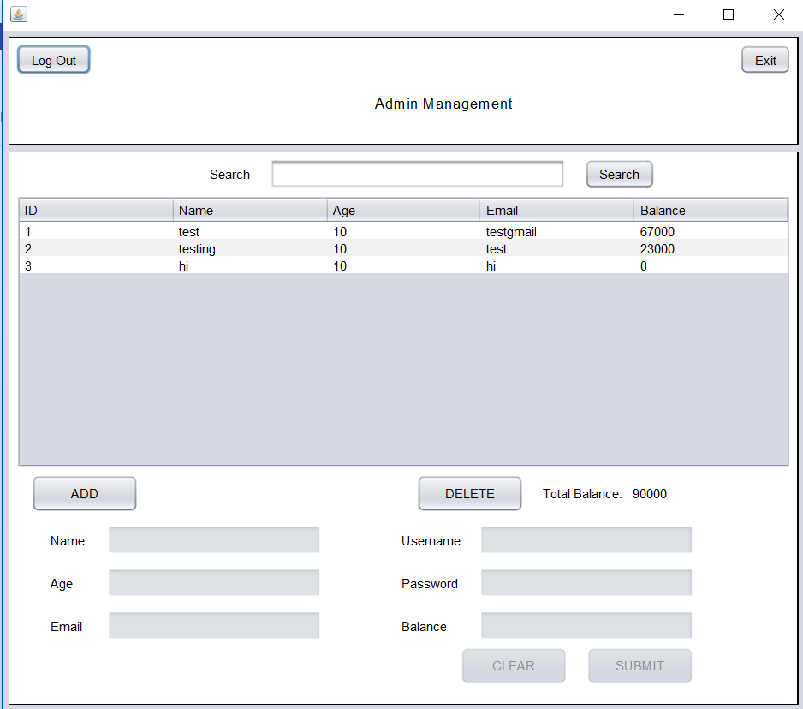

This is the admin form after the login form that shows the data of the users. They could add the data, delete it and see the total balance as well. If the table is full, the admin can search for the wanted id.

# 

This is when you pressed the add button then the text field will be enabled and the search field will be disabled.

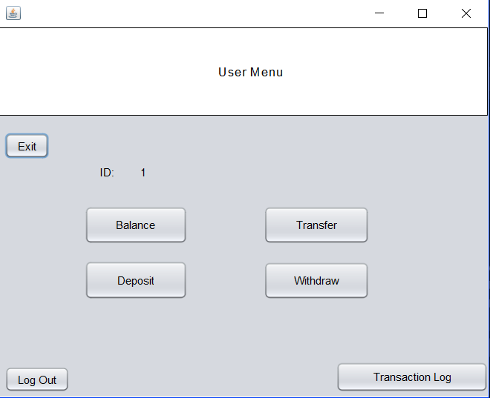

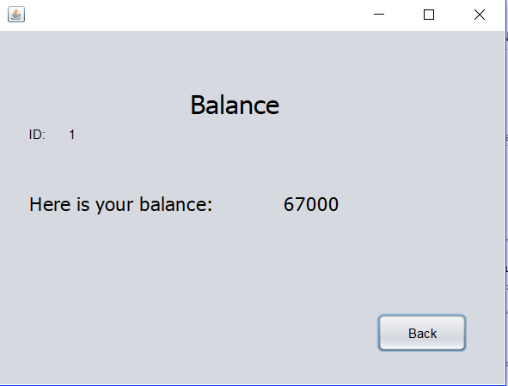This is the user form and the id is shown above the buttons.

This is the balance form that will show the ID and the balance.

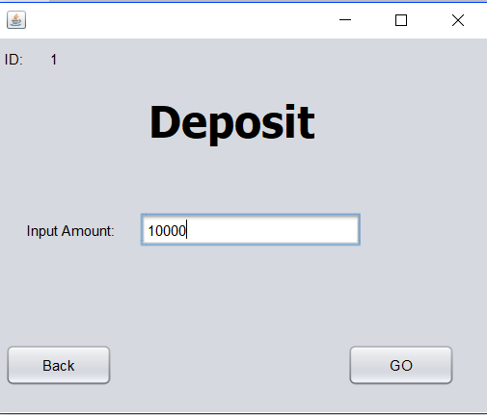

This is the deposit form which requires the user to input amount.

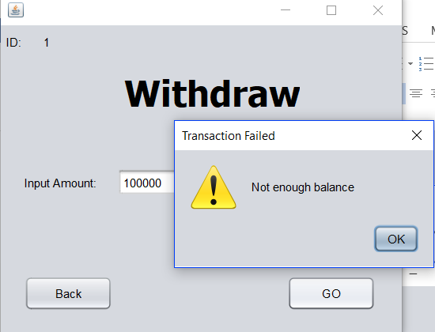

This is the withdraw form that will check if the amount inputted is more than the balance or not. If it has not enough balance, it will give notification.

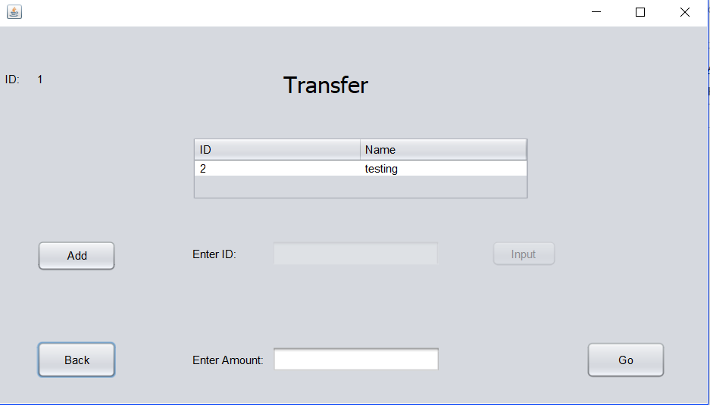

This is the transfer form that can search for the wanted id and show the name, then enter the amount and click Go.

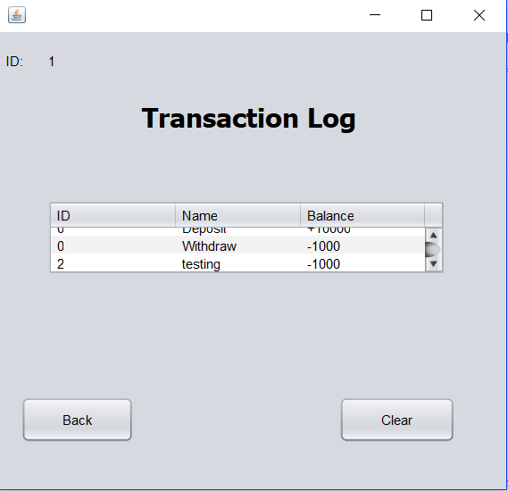

This is the transaction log that will show your transaction history such as transfering money or depositing or withdrawing.

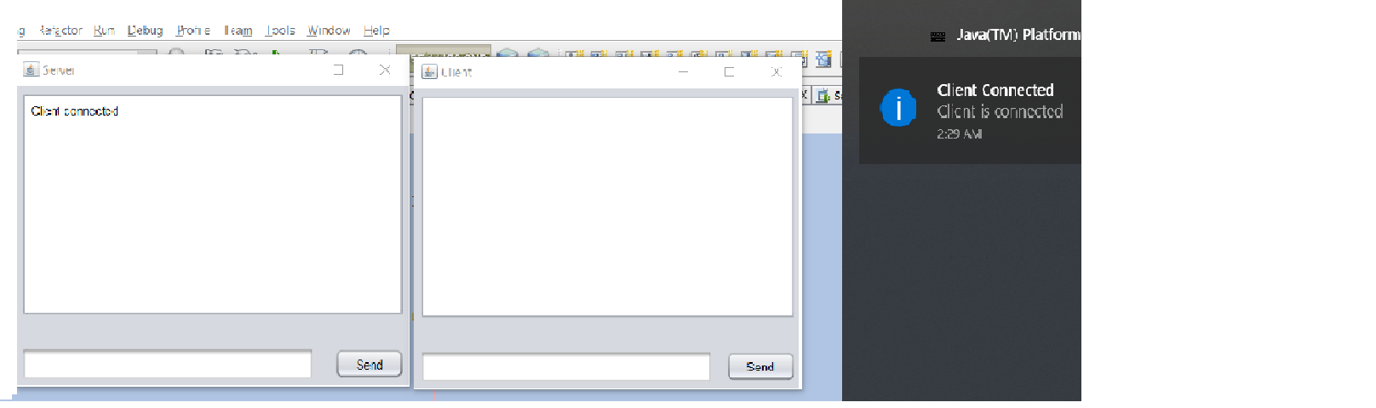

This is theh server and client application. So, whenever the client has connected to the server, the server will receive a notification that the client has connected and there will be a message saying “client connected”.

# Lessons Learned

## Use of Swing

Swing is a graphical user interface that is used in Java. It could have label, text field, button, text area, and many more features. We could make the template manually by code or just drag and drop and resize it as we want. It is very useful for people that don’t really know on how to use computer as they could access the program easily with the graphical user interface as it’s mostly just buttons.

1. **Use of mySQL**

mySQL is a database language that I learned during the process on making this project. There are lots of query that can be used in mySQL such as inserting the data, updating the data, deleting data, and reseting the increment of the column that uses auto increment. Also, I learned on how to use the database efficiently and can return the value of it by putting them inside a list so that the value can be returned and compared for validations.

1. **How to make a server-client connection**

I learned on how to make a server-client connection with single thread by sending a message with writeUTF and read it with readUTF. Also, I understand how to make it with GUI and make it as simple as possible like a messenger. Furthermore, I understand how the connection work using socket and accepting the client while using the try catch exception.

1. **Making notification**

I learrned on how to make notification windows for java program. Because of that, I know that there is a data type that can initialize all local variable called ‘var’. Furthermore, I learned on how to use tray as the box of the notification, image as the symbol for the notification sign, and trayicon to display the data we inputted inside the notification box.

# Problems overcame

There are quite many problems for my project as I need to try some new things to use such as using mySQL but I can’t return the value inside of the database. I tried to search and asked everyone until finally my teaching assistant can help me to solve the problem by returning a list with a class properties so that I could get the value of the database inside of the list. So, the database data is transferred into the list. Then, I could compare them for the login, checking the balance, adding the balance, subtracting it, and make some other functions from it.

Also, the usage of swing was really hard for me since I don’t know how to pass the id from one frame to another frame. I tried to search google for the solution and ask my friend who understood using swing. Finally, I understood on passing the variable value by searching google and watch some youtube videos related to the topic that I didn’t understand. I tried to learn and implement it in my program until I know how to do it properly.

Furthermore, using socket for connection is actually a new thing for me which results many error during my first trial. However, I decided on checking more websites and watching some related videos to it even ask my friends whose project are using sockets to understand more about how the server accept the client, sending the message, and reading the message. I understand on making the messenger while watching some videos and try to implement it and make it as a GUI because it is not easy to insert the code into the GUI as you need to understand more about the variable that has to be static and putting in the try catch block as well. Finally, I succeeded on overcaming all of my problems by doing several searchings and asking my friends that understand on the topic that is new for me.

# References

* Teaching Assistant Yoksan
* Lecturer Sir Minaldi
* <https://www.youtube.com/watch?v=kqBmsLvWU14>
* <https://www.youtube.com/watch?v=SBLVtH0SGQY>
* <https://www.instructables.com/id/Creating-a-Chat-Server-Using-Java/>
* <https://www.javatpoint.com/java-swing>
* <https://www.technetexperts.com/web/windows-push-notification-service-in-java-application/>
* <https://stackoverflow.com/questions/34490218/how-to-make-a-windows-notification-in-java>